[Agency Logo & Information] 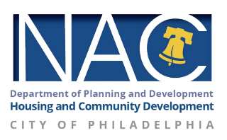

[DATE HERE]
Dear Homeowner,

First and foremost, I hope you and your loved ones are faring well amidst these dynamic times.

My name is John Doe, and I work with Organization’s Name NAC Program to deliver vital information and connect people to programs that help them live comfortably in their homes. I am sending this letter and attached flyer because the City of Philadelphia wants to ensure that you are familiar with the Save Your Home Philly Hotline (215-334-4663) and its benefits.

This Hotline exists to connect homeowners facing mortgage and/or tax foreclosure to City-funded Housing Counselors, who serve as client advocates and advisors in order to prevent foreclosure and keep people in their homes.

You are receiving this letter because the City of Philadelphia’s outreach lists states that you are currently at risk of mortgage or real estate foreclosure. If this is in error, please call the Hotline to rectify the situation. If you have not yet sought assistance, we advise calling the Hotline ASAP to save your home.

For your convenience, the City of Philadelphia Housing Counselors are offering appointments in person or virtually (by phone and/or video).

If you have questions, need further assistance, and/or wish to schedule an appointment with a Housing Counselor, please do not hesitate to contact me: phone number or email address

Wishing you and your family all the best.

Warmly,

[Your Information]
[Job Position]
[Agency]
[Contact information]

