Agency Logo Here 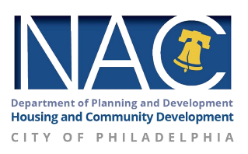

[DATE HERE]
Dear Homeowner,

First and foremost, I hope you and your loved ones are faring well amidst these dynamic times.

My name is John Doe, and I work with Organization’s Name NAC Program to deliver vital information about tangled titles and connect people to programs that help them keep, own and live comfortably in their homes. I am sending this letter and attached flyer because the City of Philadelphia wants to ensure that you are aware that help is available through the City of Philadelphia’s Tangled Title Program.

If you live in a house, you believe you own, and your name is not on the deed or you are unsure if your name is on the deed, you may have a tangled title. Please call the Save Your Home Philly Hotline (215-334-4663) for assistance.

For your convenience, Greater Philadelphia Asian Social Service Center (GPASS), HopePHL, and Strawberry Mansion NAC are offering appointments in person or virtually (by phone and/or video) to help Philadelphia homeowners fix their tangled titles. For information about how to contact these organizations, see the attached flier.

If you have questions, need further assistance, and/or wish to schedule an appointment, please do not hesitate to contact me: phone number or email address.

Wishing you and your family all the best.

Warmly,

John Doe
NAC Coordinator

